PEATLAND-ES-UK LONG-TERM EXPERIMENT

EXPERIMENTAL DESIGN

The three sites, Nidderdale, Mossdale and Whitendale are all located in north-west England and were chosen based on a set of key criteria: all are classed as heather-dominated blanket bog (see Figure 2) with a mean peat depth of over 1m and were managed as grouse moors. Typically, the sites were managed with a 10-15-year burn rotation and all had a long history of burning (more than 100 years). All sites have more than 50% Calluna cover, with at least some existing bog vegetation in the form of Eriophorum and Sphagnum species, and show a low stocking density of <0.5 ewes ha⁻¹. The sites allowed for a pair of similar sized (~10 ha) sub-catchments, each with a main stream, and their proximity allowed reaching all within a day when necessary.
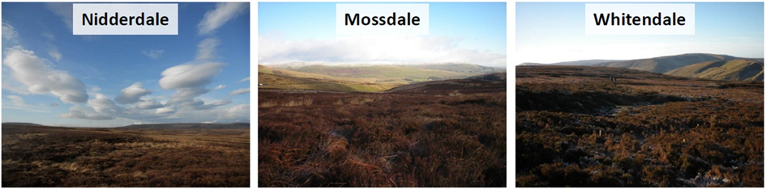
Figure 2: Site conditions as observed by ground-level pictures (credit A. Heinemeyer) taken in winter 2012 at each site (Nidderdale, Mossdale and Whitendale). Note the heather and sedge cover (mostly cotton-grass (Eriophorum spp.)) dominated blanket bog vegetation.
Management for each site consisted of two similar adjacent sub-catchments being allocated either a burning or mowing management at the catchment scale, with various plot-level managements: uncut, brash removal or Sphagnum pellet addition. Within each sub-catchment, four experimental blocks each with one 5 x 5 m plot-level (with a 5m gap between each plot) replicate per management treatment, were defined with at least 50m between blocks (see Figure 3).

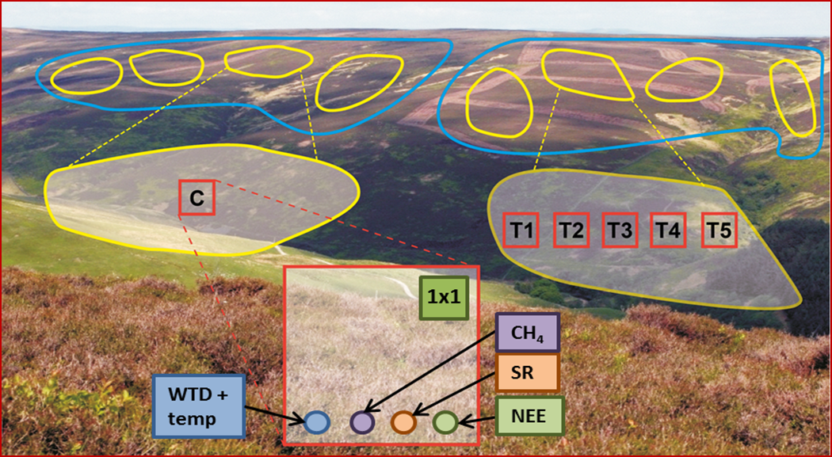
Figure 3: Schematic site layout of the two sub-catchments (blue outlines) with four blocks (yellow outlines) each. Each plot (red outlines) is 5x5 m. Control (C) plots were burnt (FI) and the additional C1 plots were burnt with Sphagnum propagules subsequently added (FI+Sp). Treatment (T1-T5; randomly allocated) plots in the mown sub-catchment were either mown with brash left (LB) or brash removed (BR), were mown with Sphagnum propagules added (LB+Sp; BR+Sp) or were left uncut as ‘do nothing’ comparisons (DN). Each plot contained a corner 1x1 m area (green square) for detailed vegetation monitoring, a circle for CH₄ and total soil respiration (purple circle), periodically cut and therefore root-free soil respiration (SR_{c}) areas for decomposition (brown circle), and NEE flux (green circle) measurements and a mesh cage with a dipwell and temperature logger (blue circle).
Diverging management of either burning or mowing (see Figure 4) started with the first management phase in 2013 (after one year of background monitoring pre-management change), on all blocks and on three additional areas per sub-catchment (~0.24 ha each). In the second management phase in 2015, five new areas (~0.25 ha each) within the sub-catchments were burnt or mown.

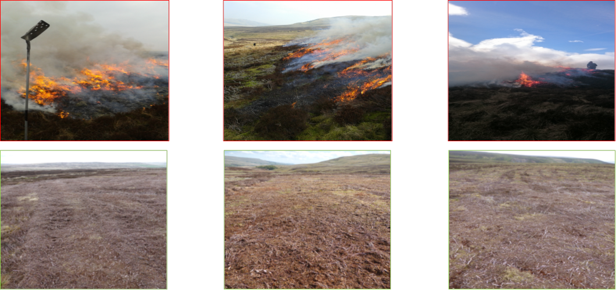
Figure 4: The six sub-catchments (from left to right: Nidderdale, Mossdale, Whitendale) shown during burning (top row) and after mowing (bottom row) in March/April 2013. Also note the air pollution (visible as smoke) impact during the burning (photo credit A. Heinemeyer).

Each site has a V-notch flow weir at the outflow of each sub-catchment to measure flow rates and, by considering rainfall data from a weather station, calculate water budgets. In one corner of each plot, a logger measures the soil temperature, another logger records daily water tables and a peat rod allows capturing long-term peat accumulation. Additionally, each plot contains a Rhizon sampler for periodical sampling of pore water. Circular flux areas for repeated methane (CH₄) and total CO₂ soil respiration (SR), root-free SR (SR_{c}) and net ecosystem exchange (NEE) measurements are seasonally monitored along one side. A 1 x 1m sub-plot and the entire 5 x 5 m plots are undergoing annual detailed vegetation monitoring. Refer to Figure 3 for the overall context.

