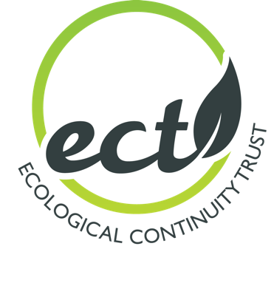

ECT Trustee Person Specification

Trustees are the people responsible under the governing document of the Ecological Continuity Trust (hereafter ECT) for controlling the management and administration of the ECT. The Trust is looking to recruit trustee(s) willing to commit time and effort to supporting the Trust’s aims and objectives: (1) supporting long-term experiments by providing much needed funds through our grants scheme and emergency repair funds; (2) developing a strategic network of long-term ecological experiments; (3) safeguarding existing high quality experiments and data; (4) ensuring that new facilities are planned for the long-term; (5) promoting the value of long-term ecological studies to society.

General Responsibilities
- To ensure that the ECT complies with its governing document, charity law, company law and any other relevant legislation or regulations.
- To ensure that the ECT pursues its objects as defined in its governing document.
- To ensure the ECT applies its resources exclusively in pursuance of its objects (the charity must not spend money on activities which are not included in its own objects, no matter how worthwhile or charitable those activities are).
- To contribute actively to the Board of Trustees' role in giving firm strategic direction to the ECT, setting overall policy, defining goals and setting targets and evaluating performance against agreed targets.
- To safeguard the good name and values of the ECT.
- To ensure the effective and efficient administration of the ECT.
- To ensure the financial stability of the ECT.
- To protect and manage the property of the Charity and to ensure the proper investment of the Charity's funds.
- To appoint the Executive Director and monitor his/her performance.
Specific Duties
In addition to the above statutory duties, each trustee should use any specific skills, knowledge or experience they have to help the Board of Trustees reach sound decisions. This may involve:
- Scrutinising Board papers
- Assessing site registration and grant applications
- Contributing to and sometimes leading discussions
- Providing guidance on new initiatives and fundraising
Experience, Skills and Knowledge Required
Experience
- At least 10 years’ research or consultancy in ecology or related subject, AND/OR
- Some experience of trusteeship or other charity involvement, AND/OR
- Some experience of charity fundraising and/or interacting with policymakers
Skills
- Strategic vision
- Good, independent judgment
- Ability to think creatively
- Ability to work effectively as a member of a team
- Willingness to speak their mind
Knowledge
- Degree or higher qualification in ecology or related subject, AND/OR
- Understanding and acceptance of the legal duties, responsibilities and liabilities of trusteeship

